Ride Booking Analytics Dashboard Using R and Apache Hive

STQD6324 Data Management

Student Information
Name: REN SHINENG
Student ID: P161565
Semester: Semester 2 2025/2026
Universiti Kebangsaan Malaysia (UKM)

1. Introduction
This project develops an interactive Ride Booking Analytics Dashboard using R Shiny. The objective is to demonstrate data management, data integration, data processing, and visualization techniques using multiple approaches.
The project uses a ride-booking dataset containing booking information, vehicle types, booking values, ride distances, cancellation status, ratings, and payment methods.
Three different data processing approaches were implemented:
- Direct data processing using R.
- Data processing using Apache Hive and exporting cleaned data through WinSCP.
- Direct connection between RStudio and Hive using ODBC.
The final output is an interactive dashboard that provides booking analytics, revenue insights, cancellation analysis, and predictive analytics.

2. Project Objectives
The objectives of this project are:
- To manage large ride-booking data efficiently.
- To perform data cleaning and preprocessing.
- To integrate Hive with RStudio.
- To visualize business insights using Shiny Dashboard.
- To develop a cancellation risk prediction model.

3. Dataset Description
The dataset contains ride-booking transaction records.
Main attributes include:
Attribute | Description
booking_id | Booking identifier
customer_id | Customer identifier
Vehicle_Type | Vehicle category
Booking_Status | Booking status
Payment_Method | Payment method
Pickup_Location | Pickup location
drop_location | Destination location
Ride_Distance | Distance travelled
Booking_Value | Booking revenue
Driver_Ratings | Driver rating
Customer_Rating | Customer rating
Is_Cancelled | Cancellation indicator
Dataset Size:
- Total Records: 103,024
- Cancelled Records: 39,057
- Completed Records: 63,967

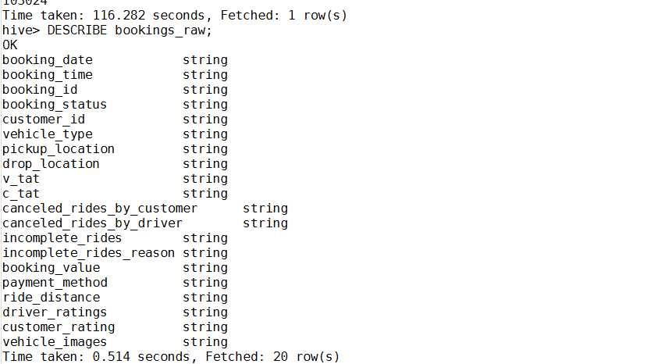

4. Methodology
The project was implemented using three different approaches.

4.1 Approach 1: Direct Data Processing Using R

Process Flow
CSV Dataset → RStudio → Data Cleaning → Dashboard
Steps:
- Import CSV dataset into R.
- Clean missing values.
- Create derived variables.
- Generate dashboard visualizations.
- Build cancellation prediction model.
Technologies Used:
- R
- Tidyverse
- Lubridate
- Plotly
- DT
- Shiny Dashboard

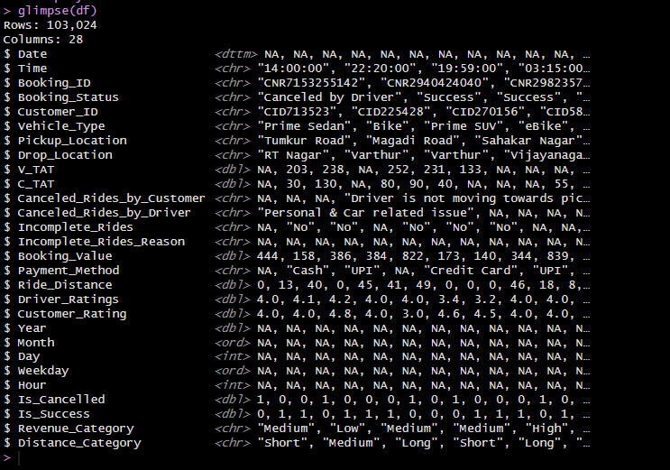

4.2 Approach 2: Hive Data Processing + WinSCP Export

Process Flow
CSV Dataset → HDFS → Hive → Data Cleaning → WinSCP Export → RStudio Dashboard
Steps:
- Upload CSV file to HDFS.
- Create Hive table.
- Execute HiveQL data-cleaning queries.
- Export processed dataset.
- Download cleaned data using WinSCP.
- Load cleaned dataset into RStudio.
- Build dashboard.
Example Hive Operations:
- NULL handling
- Data transformation
- Derived variable generation
- Aggregation
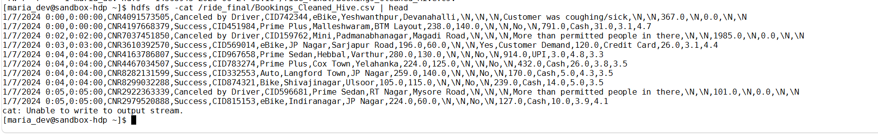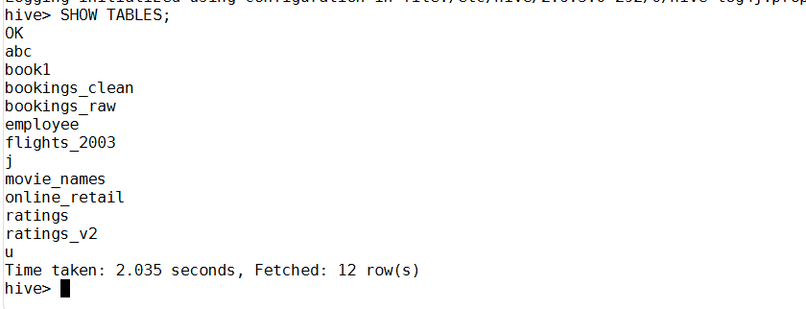
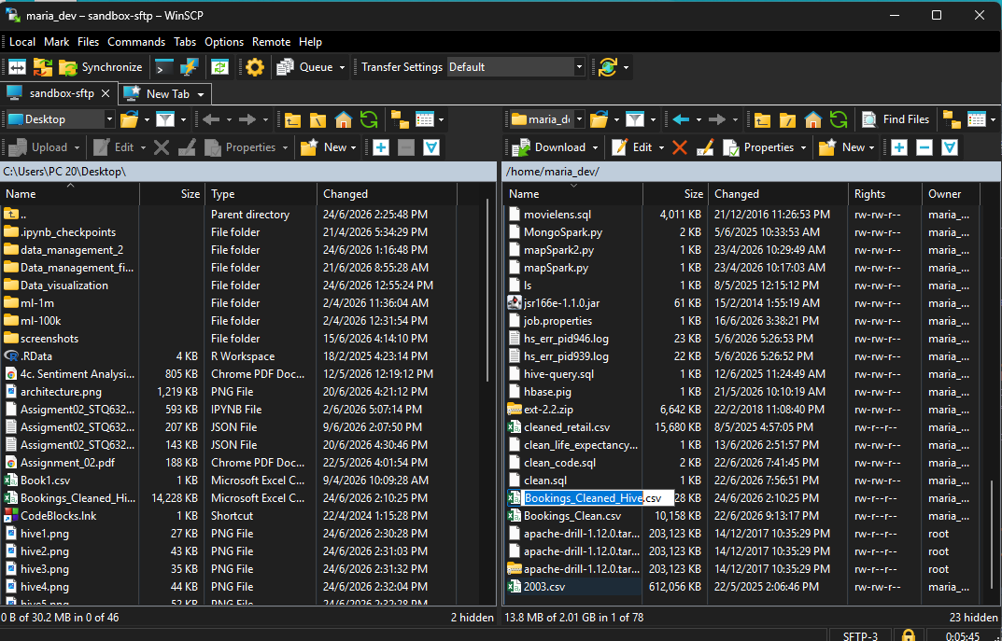

4.3 Approach 3: Direct Hive Connection Using ODBC

Process Flow
CSV Dataset → HDFS → Hive → ODBC Connection → RStudio Dashboard
This approach eliminates the need to export files manually.
Steps:
- Configure Hive ODBC Driver.
- Create DSN connection.
- Connect RStudio to Hive.
- Retrieve Hive tables directly.
- Build dashboard from live Hive data.
Advantages:
- Real-time access.
- No intermediate CSV files.
- Better integration between Hive and R.
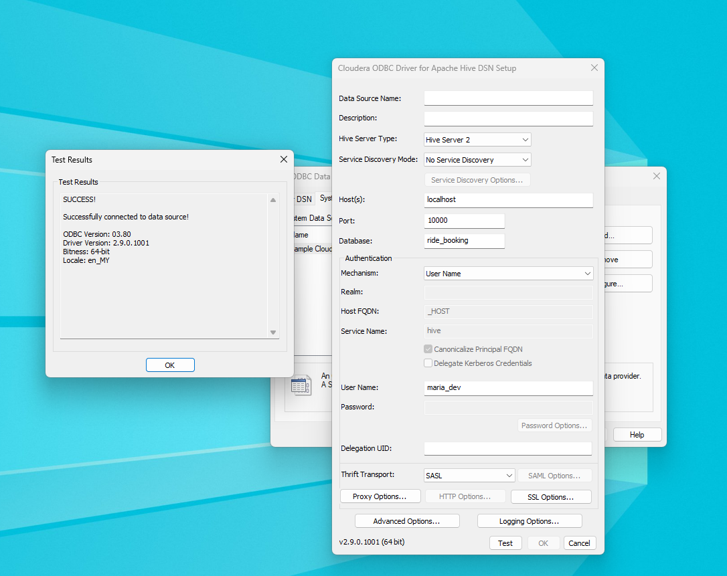
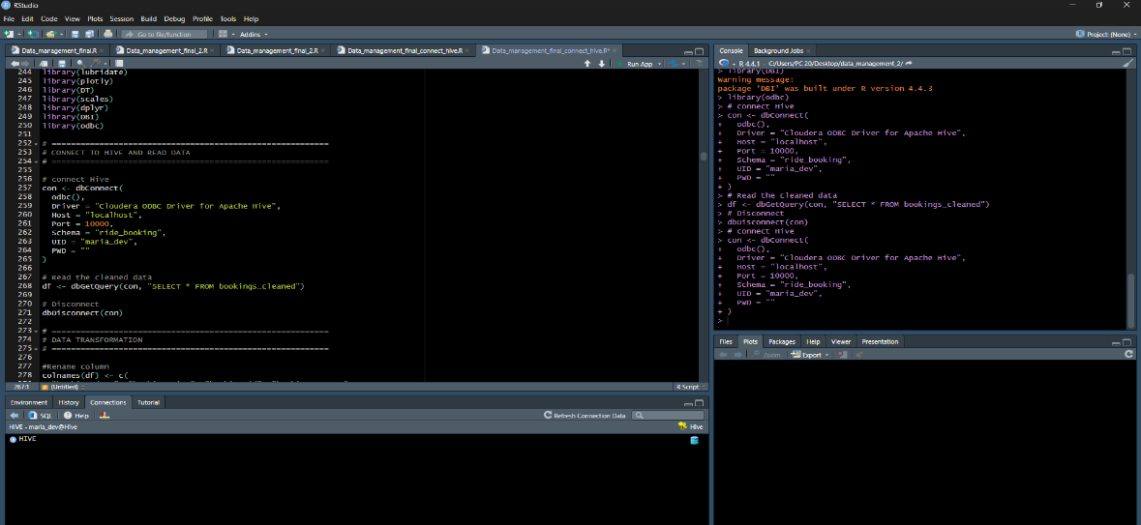

5. Dashboard Development
The dashboard was developed using Shiny Dashboard.
Main features include:

5.1 KPI Monitoring
- Total Bookings
- Total Revenue
- Cancellation Rate
- Average Distance
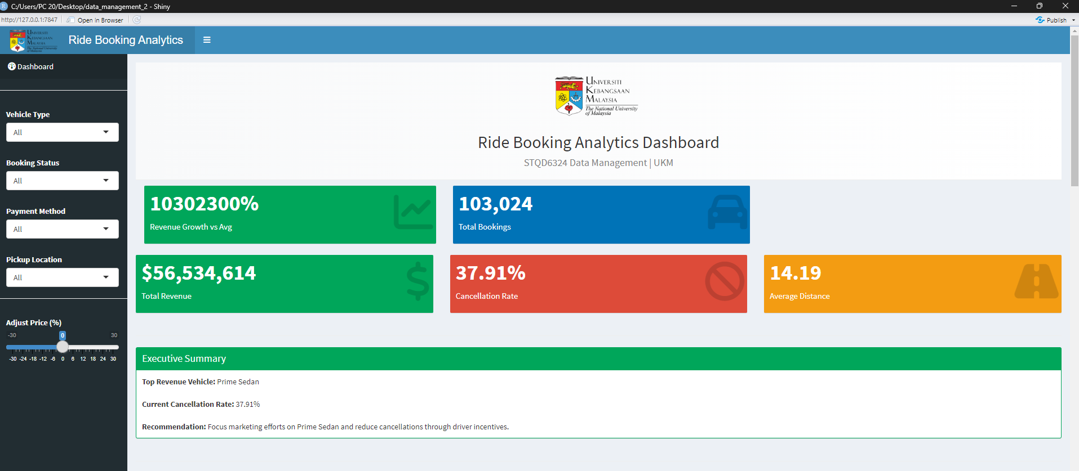

5.2 Executive Summary
Automatically generated summary describing:
- Highest revenue vehicle type
- Current cancellation rate
- Business recommendations
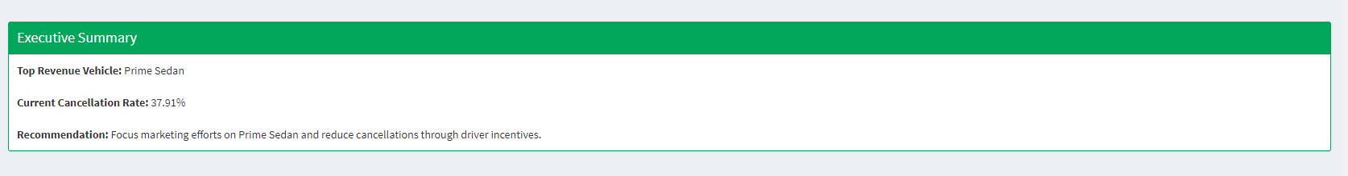

5.3 Booking Trend Analysis
Interactive booking trend visualization over time.
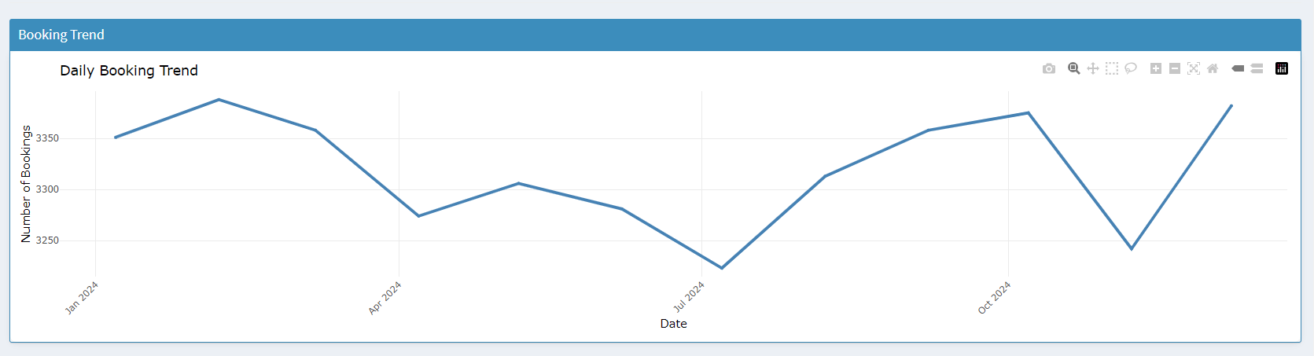

5.4 Revenue Analysis
Revenue distribution by vehicle type.
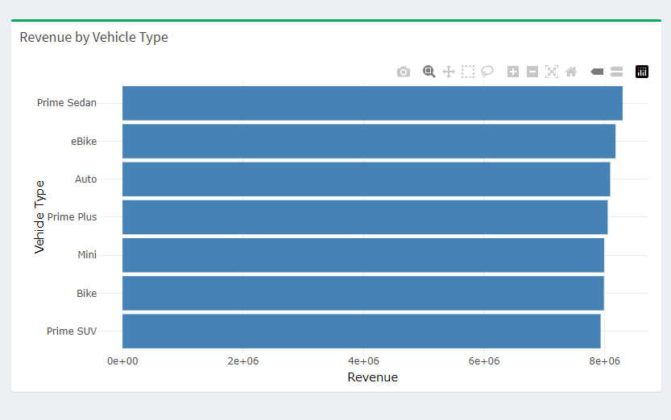

5.5 Payment Method Analysis
Payment method distribution analysis.
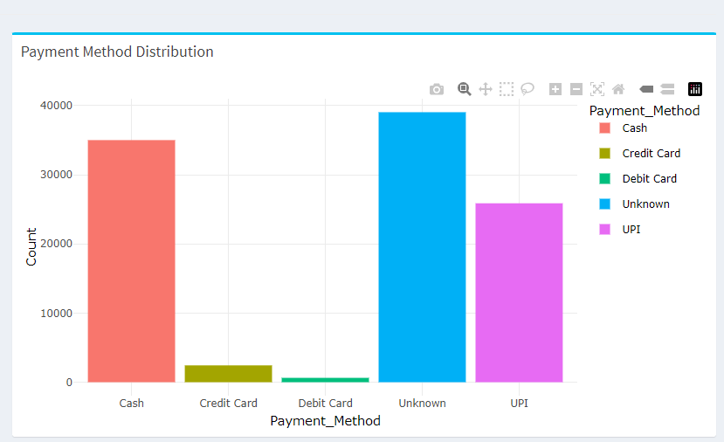

5.6 Cancellation Analysis
Booking status and cancellation analysis.
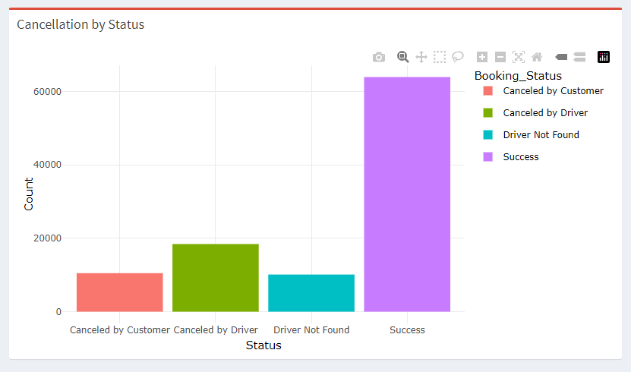

5.7 Ratings Analysis
Customer rating distribution visualization.
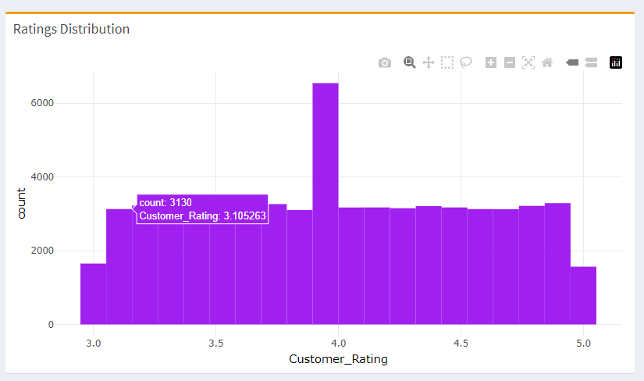

5.8 Price Adjustment Simulation
Interactive simulation showing estimated revenue after price adjustments.

5.9 Cancellation Risk Prediction
A logistic regression model was implemented to estimate booking cancellation risk.
Predictor Variables:
- Ride Distance
- Booking Value
- Vehicle Type
- Payment Method
Output:
- Estimated cancellation probability
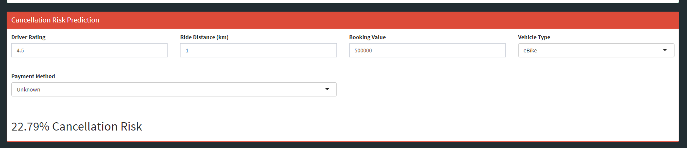

5.10 Data Explorer
Interactive table with filtering functionality.
[Insert Data Explorer Screenshot]

6. Results and Discussion
The dashboard successfully provides business insights regarding:
- Revenue performance
- Customer booking behaviour
- Cancellation trends
- Vehicle usage patterns
Among the three approaches:
Approach | Advantages | Limitations
R Only | Simple implementation | Limited scalability
Hive + WinSCP | Better data management | Requires manual export
Hive + ODBC | Real-time integration | More complex configuration
The Hive + ODBC approach provides the most efficient and scalable solution.

7. Conclusion
This project successfully demonstrates the integration of Apache Hive and RStudio for ride-booking analytics.
Three different implementation approaches were evaluated:
- Direct R processing.
- Hive processing with exported datasets.
- Direct Hive-ODBC integration.
The developed dashboard enables interactive analysis, business reporting, and predictive analytics. The project highlights the importance of data management technologies in supporting modern business intelligence applications.

References
Apache Hive Documentation
R Project Documentation
Shiny Documentation
ODBC Documentation
UKM STQD6324 Data Management Course Materials

